More information on destinations open for applications is available at Mobility-Online portal. Select a degree programme from "Study field" and the right "Academic year". The search results show all those host universities where you can apply via the chosen degree programme.
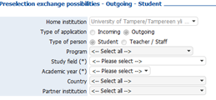
"Display details" shows additional information concerning the host university, the language requirements, study options, etc. Here is a picture of the info icon:
You can access the application form with your TUNI username and password. Please fill in the application form carefully. Your personal information comes to the application form automatically from the student register. If you need to update your information, for example your address, make the necessary changes in NettiOpsu and notify your mobility coordinator. This information will not be updated to the application form automatically.
You can apply for up to three destinations. One destination means one university or network (BCI, ISEP, north2north, Nordplus and Nordlys). If you apply for a university belonging to a Network, first select the name of the network and then 'Other' for the name of the country. Please draw up a motivation letter and a study plan for each university you are applying for within the network. Place the motivation letters and the study plans in the relevant field in order of preference.
PLEASE NOTE! You are able to fill in one application form per application period!
After you have filled in the application form, you will receive a link to your email address. Log in to Mobility-Online and fill in the necessary information. In case you do not receive the e-mail message concerning registration, please check your spam filter.
Your Mobility-Online account has "Necessary steps" which you need to complete before the application is complete:
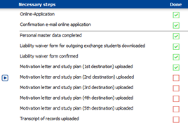
Prepare the necessary enclosures and upload them to your Mobility-Online account. You will need:
- a motivation letter and preliminary study plan (pdf)
- transcript of records (pdf, the unofficial transcript from NettiOpsu is ok)
- passport size photo (jpg)
Write a separate motivation letter and preliminary study plan for each host university. If you are sending your application to a network, write a motivation letter separately for each university you are applying to.
The motivation letter and study plan must be written in the language in which the studies will be organised in the country of destination. Among other things, list the following in your motivation letter.
- How the exchange period will benefit your studies at Tampere University.
- How the exchange will benefit your career plans.
- Why you are applying to the destination in question at this specific phase of your studies.
- Mention any factors that you think support your admission, including prior work experience, any possible volunteer work and positions of trust.
If you are studying in a separate two-year Master’s programme, also following attachments must be submitted:
- A statement from the supervisor of your Master's thesis supporting your exchange studies.
- Copies of the degree certificates or transcripts of records from your previous studies.
The enclosures must be uploaded to Mobility-Online during the application period. Without the enclosures your application is incomplete and it will not be processed.
After you have uploaded all necessary enclosures, you need to submit the application:
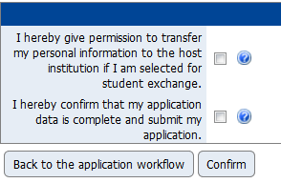
After your application is complete, you will be on this step:
You can now log out from your Mobility-Online account. Your application is now finished and it will be processed by Tampere University.

