Email encryption
You can encrypt emails to protect them from being read by anyone other than the intended recipient. Encrypting an email message in Outlook means that your email is converted from readable plain text into scrambled cipher text. Only the recipient who has the private key that matches the public key, which you used to encrypt the message, will be able to read it. Any recipient without the corresponding private key will only see an indecipherable text.

Office 365 Message Encryption Start
Click new email
Select Options
Select Permission
Select Encrypt only

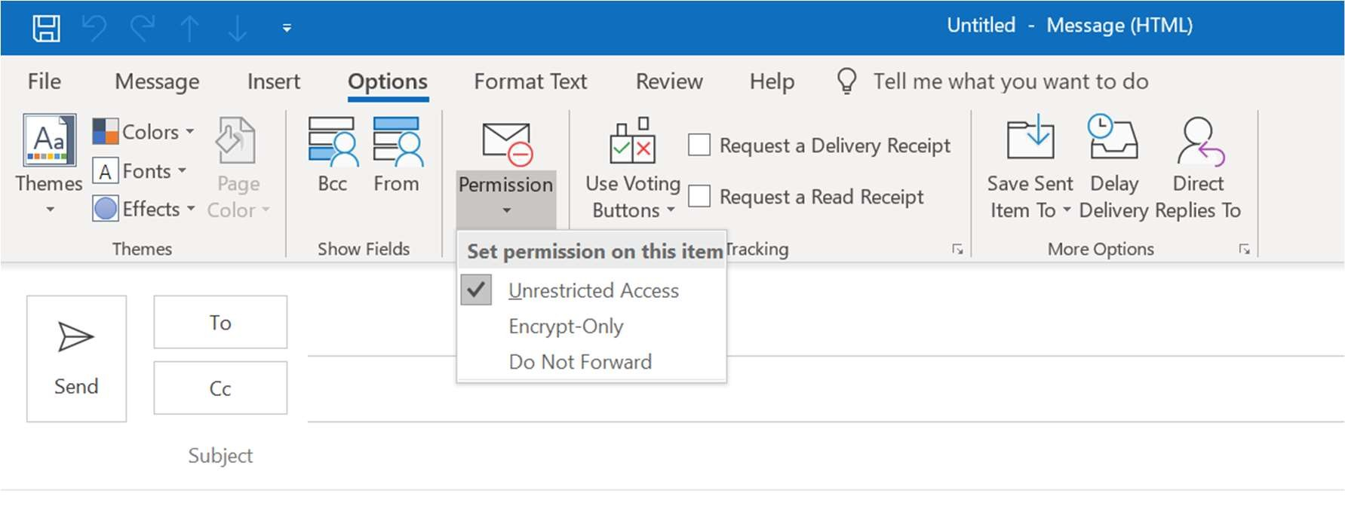
The restrictions that apply to your message will be displayed in the message window.

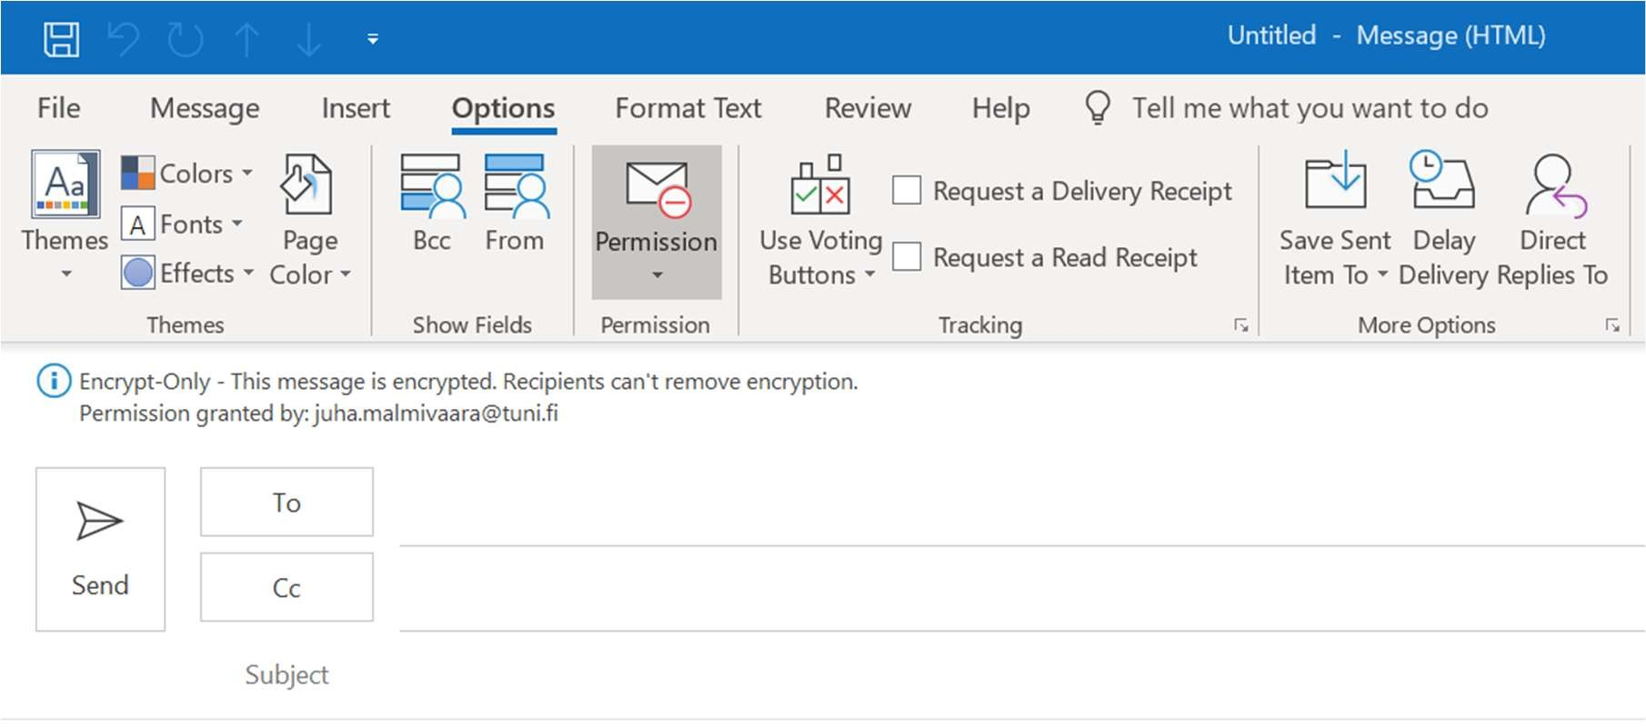

Type the email address and subject and compose your message as usual.

You can also add attachments but remember that encryption is only enabled for Microsoft 0365 products. If you need to send, for example, an encrypted PDF file, you can secure the file with a password.

The supported file types are listed at the end of this document.

When your message is ready, click Send.

When you send encrypted emails to people inside your organisation, the recipient will be able to access the message directly without providing a passcode. The recipient will see the encryption icon (a circle with a horizontal line) next to the email in the inbox.

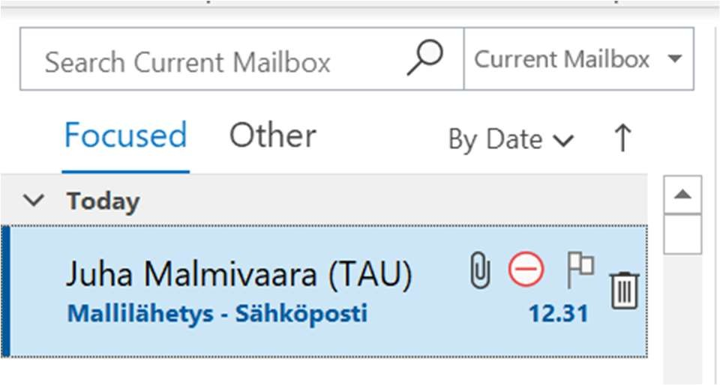

When the recipient opens the email, he or she will see a message that the email is protected.

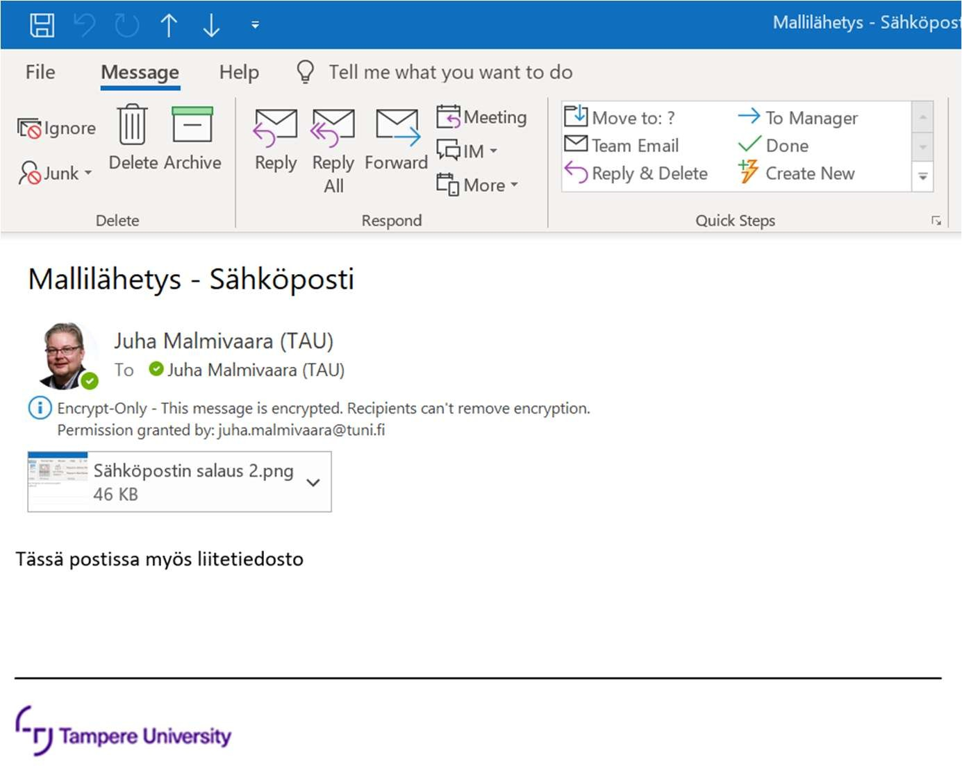

If the recipient is from outside our organisation (TUNI.FI), he or she will receive an email with instructions for how to read the encrypted message. (As scammers often use these types of emails to trick people into giving out their personal information, the message may easily be mistaken for a phishing attempt. You may want to inform the recipient that you will be sending him or her an encrypted email to avoid any misunderstanding.)
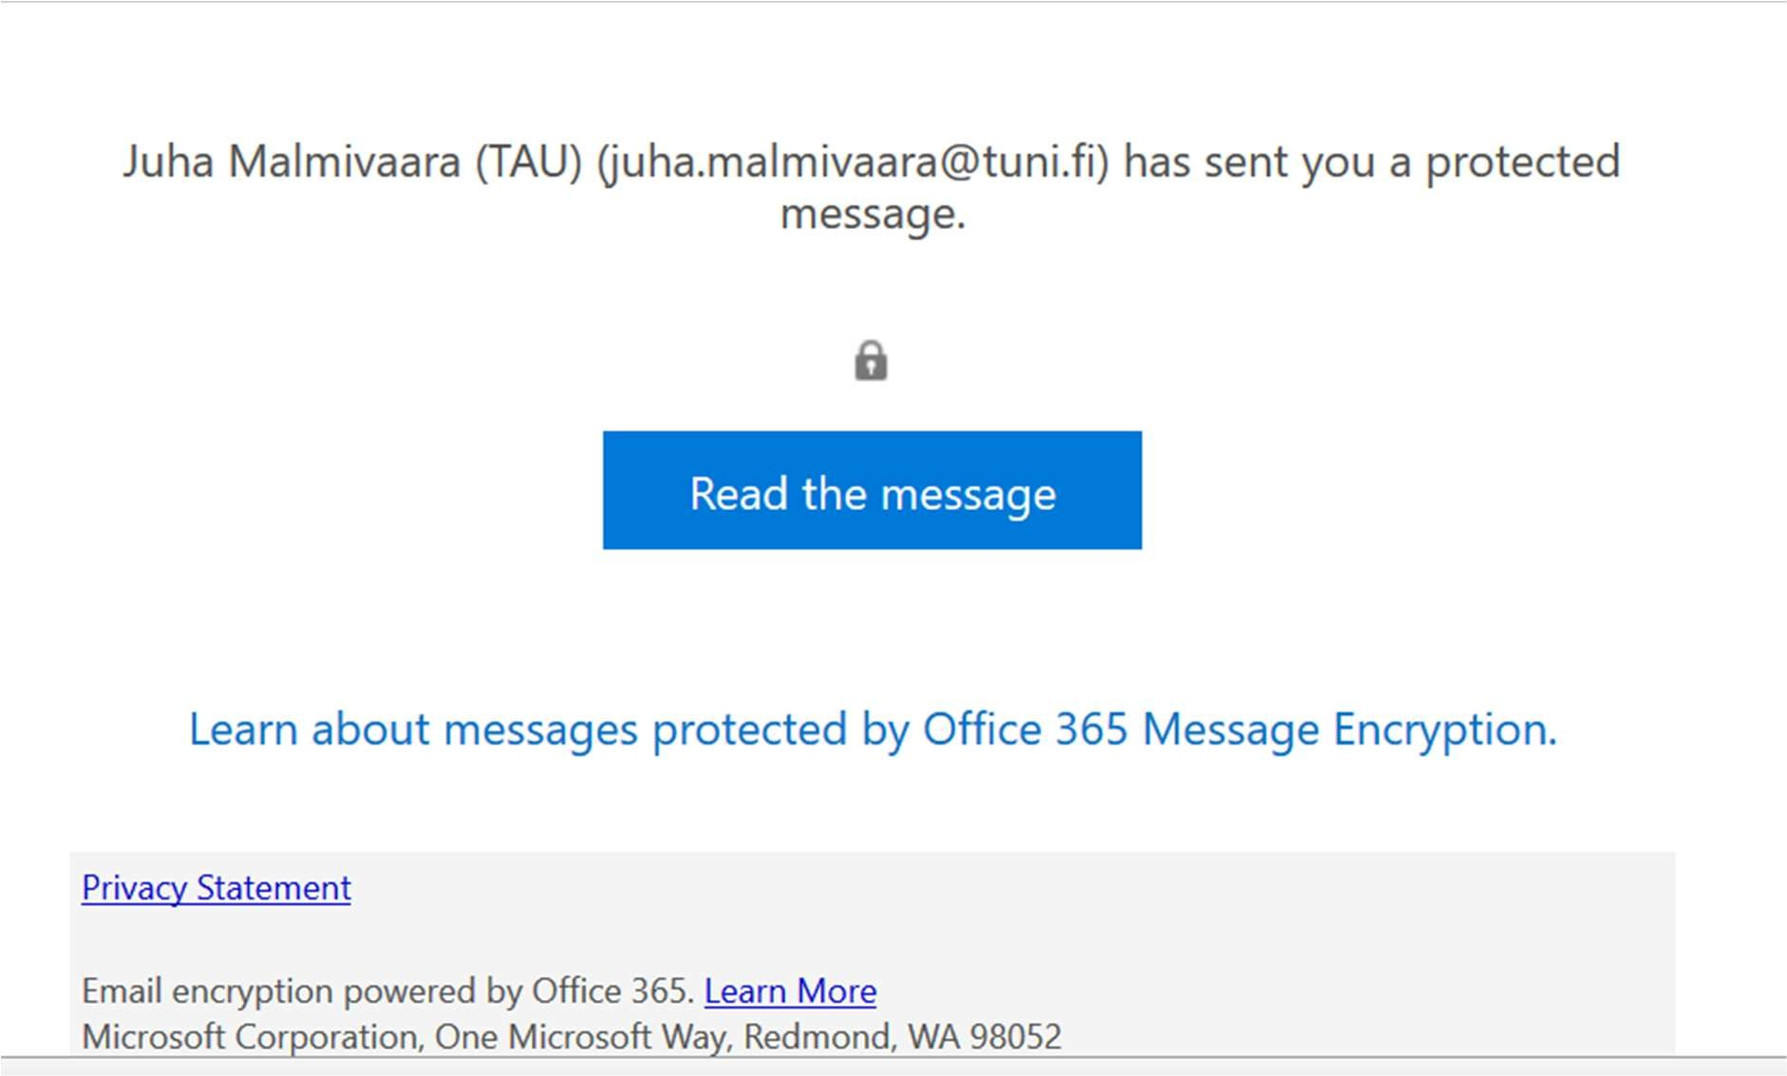

When the recipient clicks the Read Message button, he or she will be prompted to sign in to O365 or enter a one-time passcode to view the encrypted message.

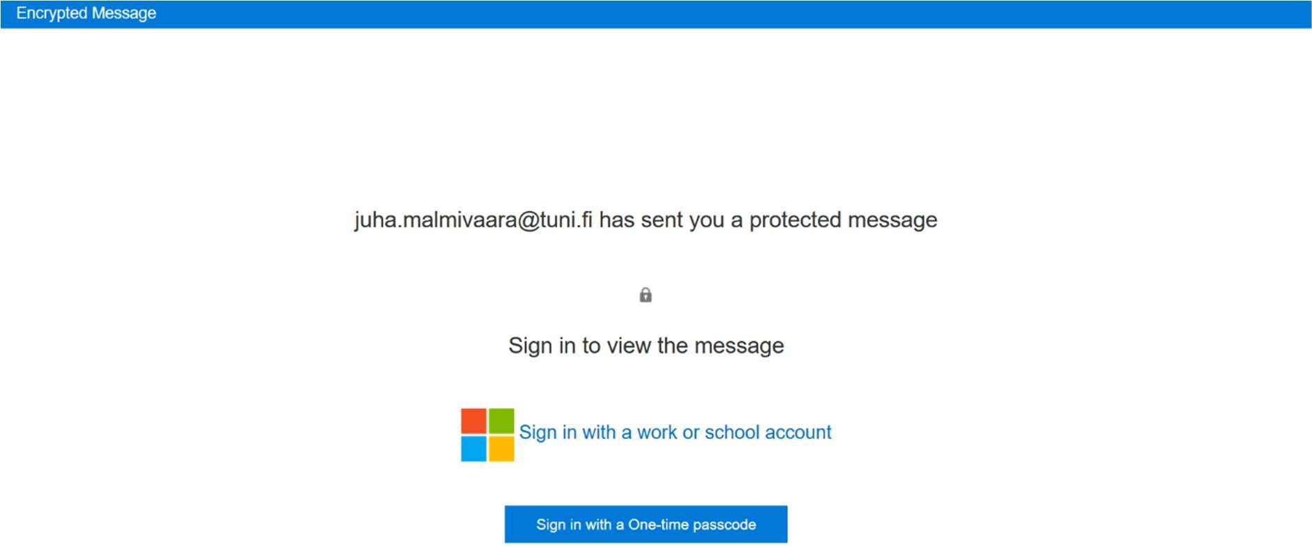

A one-time passcode is an easy way to identify the recipient.

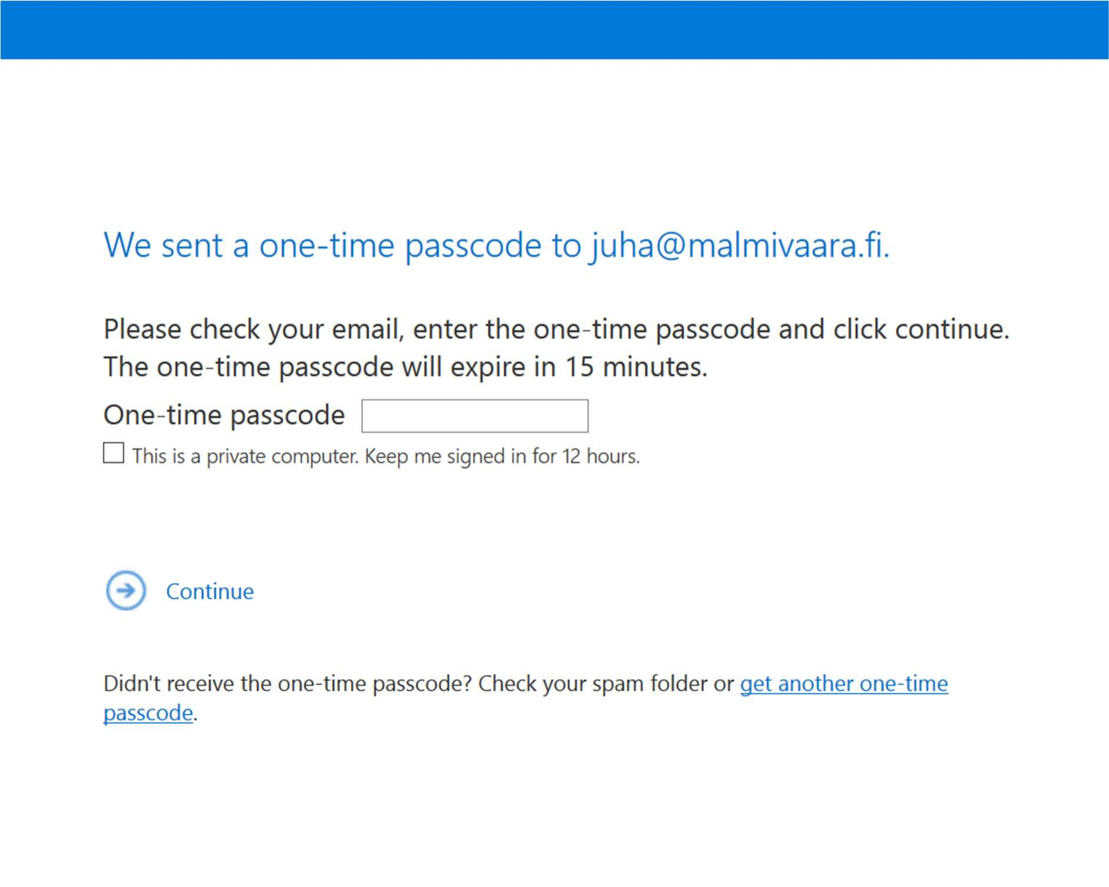

The recipient will receive a new email with the one-time passcode.

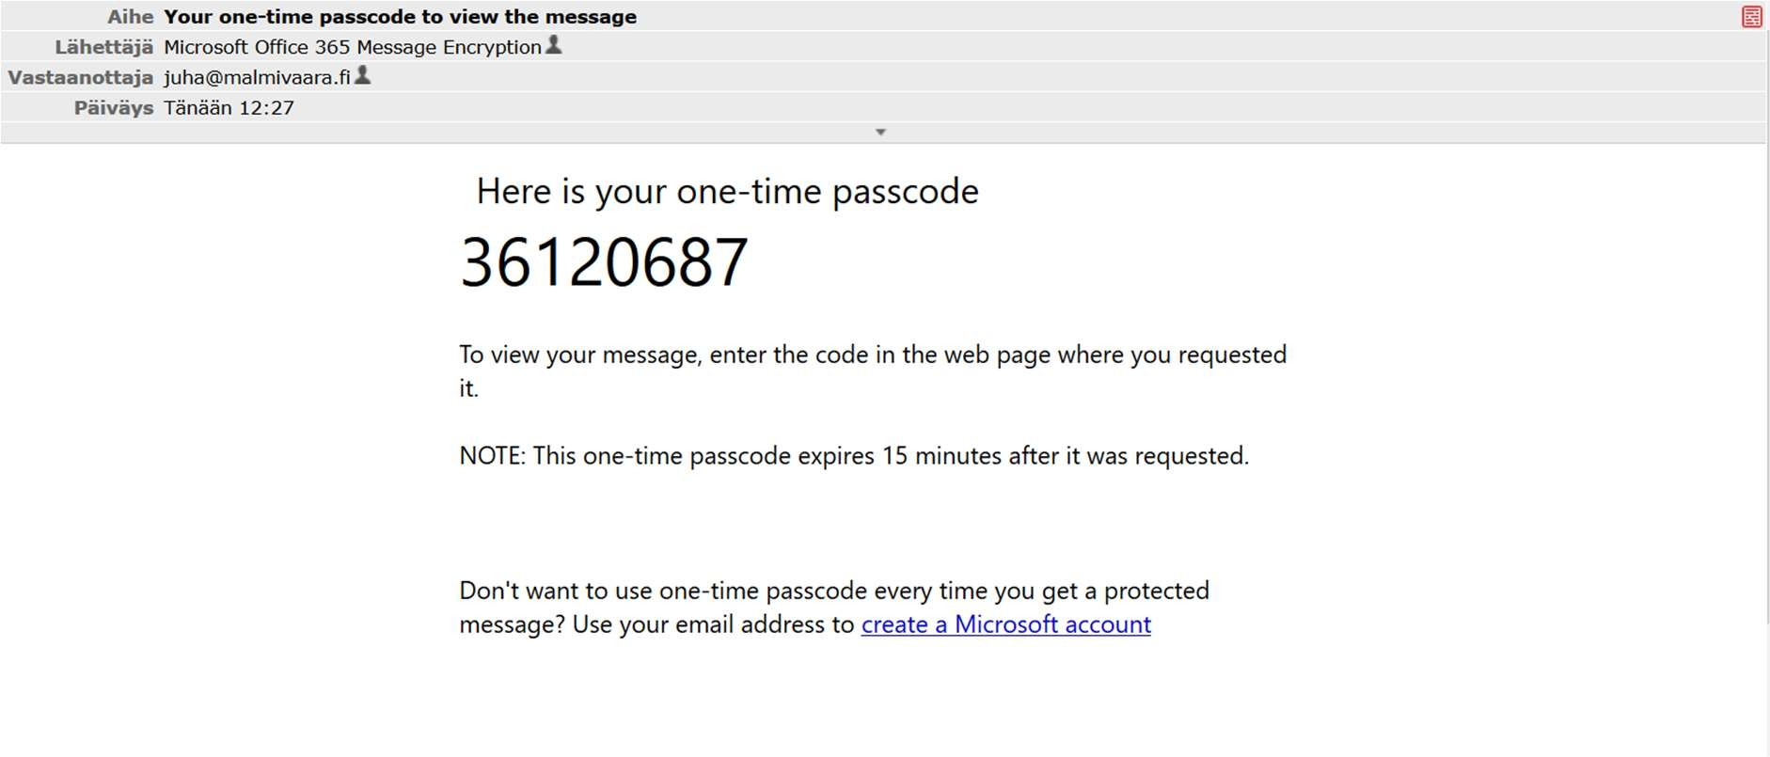

The passcode will remain valid for 15 minutes. If the passcode expires or does not work, the recipient can request a new passcode by clicking a button displayed in the browser window.

Enter the passcode to view the message.
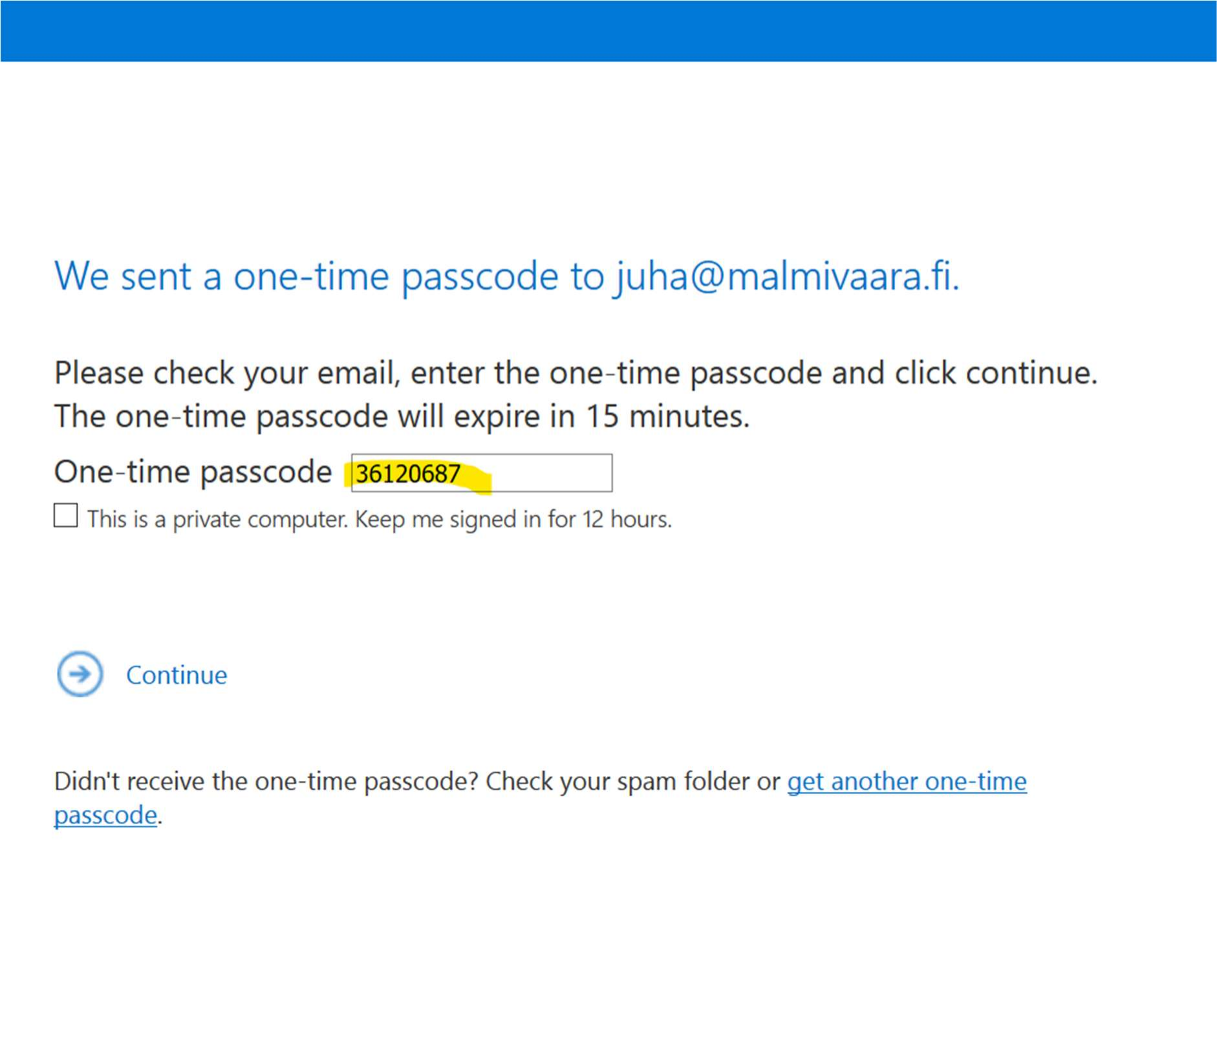

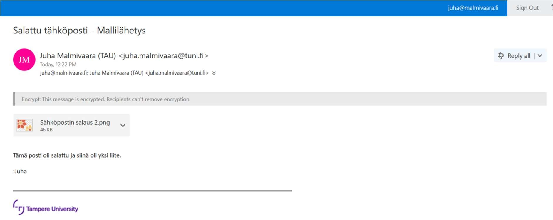

Supported file types

File type Suffix

Document .doc

Document .docx

Macro-enabled document .docm Template .dot
Template .dotx

Macro-enabled template .dotm Excel files
Workbook .xls

Workbook .xlsx

Macro-enabled workbook .xlsm Malli .xlt
Template .xltx

Macro-enabled template .xltm
Binary workbook (not XML) .xlsb
Macro-enabled add-in .xla

Macro-enabled add-in .xlam

PowerPoint files
Presentation .ppt

Presentation .pptx

Macro-enabled presentation .pptm

Template .pot

Template .potx

Macro-enabled template .potm

Slide show .pps

Slide show .ppsx

Macro-enabled slide show .ppsm Office theme .thmx
InfoPath files

Dynamic form/template .xsn XPS files
XML Paper Specification .xps

