AI operating model 0.9

General principles for the use of AI at Tampere Universities


The general principles for the use of artificial intelligence (AI) at Tampere Universities outline what the use of AI means in practice and what all users of AI should know.

This document brings together the key principles and guidelines for the use of AI but do not cover every possible use case.

When necessary, users are advised to consult other relevant institutional guidelines and exercise their professional judgement on a case-by-case basis.

SECTION | CONTENT
WHAT DOES AI MEAN? | What is AI? How can I use AI to support my work? What implications does AI have for the operations of Tampere Universities?
RULES FOR USING AI | The key principles and recommendations for the safe, responsible and appropriate use of AI.
HOW TO USE AI | AI can be used in a variety of ways. Once you know what you need to achieve, you can determine the most effective way to use AI and select the most appropriate AI tool.
TAKING AI INTO USE | The process for introducing a new AI tool at Tampere Universities.
AI AGENTS AND ASSISTANTS | Before using AI, the intended use case and the suitability of the selected AI tool must be assessed.

WHAT DOES AI MEAN?

AI is a technology that can analyse data, learn from data, and assist people with decision-making and content creation.

HOW CAN AI SUPPORT MY WORK?

AI can support a wide range of tasks, such as:
- drafting text
- clarifying information
- summarising lengthy materials
- brainstorming
- automating routine tasks

TWO MAIN TYPES OF AI

TRADITIONAL AI ANALYSES

Is based on predefined rules and models
GENERATIVE AI GENERATES

Generates new content
• data analysis
• forecasting
• decision-making support

• generates new content (text, images, code, analyses
• drafting and brainstorming

Examples:
• spam filters
• operates according to the user’s prompts

• automated form processing
• study planning tools

Examples:
• writing text

• brainstorming ideas
• creating drafts and materials
• generating images

HOW DOES THE ADVANCEMENT OF AI AFFECT THE OPERATIONS OF TAMPERE UNIVERSITIES:

RESEARCH EDUCATION

• New research fields
• New research methods
• Automated research workflows

• Transformation of learning
• AI tools for teaching

SUPPORT SERVICES COLLABORATION AND PARTNERSHIPS

• Efficient administrative processes
• AI Policy, legislation, ethical principles
• AI tools for staff
• AI expertise as a resource for society
• AI partner for industry and business

The figure above illustrates, from the perspective of the AI in Teaching and Organisation (AITO) framework, how advances in AI are expected to influence the operations of Tampere Universities in four areas: research, education, support services, and collaboration and partnerships. The AITO framework helps to identify developments to which Tampere Universities must respond strategically. Please note that the framework focuses on changes in the higher education landscape and does not address pedagogical approaches or student assessment practices.

RULES FOR USING AI

All members of the Tampere Universities community are required to comply with the AI Policy and any other institutional regulations and guidelines relating to AI.

GENERAL

You remain responsible for any content you create with the help of AI.

Always review AI-generated content and verify its accuracy.

Use only the AI tools recommended by Tampere Universities. *)

Before using AI, make sure you are familiar with the AI regulations that apply to your activity.

Use clear, specific and unambiguous prompts. This reduces the need for repeated interactions and the unnecessary use of AI tools.

You may use AI to support decision-making, but you remain responsible for the final decision.

If you are unsure whether an AI tool is recommended by Tampere Universities, stop using the tool and contact the IT Helpdesk: https://helpdesk.tuni.fi/ssc/app#/

Only use AI tools that have been centrally vetted and approved for use at Tampere Universities.

Use only AI tools provided under an organisational licence to ensure compliance with information security requirements and institutional recommendations.

If you are unsure whether a specific use of AI is permitted, contact the IT Helpdesk: https://helpdesk.tuni.fi/ssc/app#/

*) https://intra.tuni.fi/en/it-services/artificial-intelligence/ai-applications/ai-assisted-applications

This page provides an overview of the key requirements set out in the AI Policy and other institutional guidelines.

INFORMATION SECURITY & DATA PROTECTION
Before using an AI tool, make sure you are aware of any information security requirements that apply to its use. See: https://intra.tuni.fi/en/it-services/artificial-intelligence

If an AI tool falls within one of the risk categories defined by EU legislation, contact the IT Helpdesk for further assessment: https://helpdesk.tuni.fi/ssc/app#/

Only enter data allowed under the Data Classification Model into AI tools.

The use of AI tools that store or process data outside the EU is prohibited. **)

RESPONSIBILITY & ETHICS

Always disclose openly when materials have been created with the help of AI.

Use AI only when necessary and for an appropriate purpose. The more complex the task performed by an AI tool, the greater its energy consumption (for example, generating a text-based response versus generating a video).

Only use AI tools that can be trusted to meet appropriate ethical standards. If you are unsure, please contact the IT Helpdesk: https://helpdesk.tuni.fi/ssc/app#/

If you suspect that an AI tool does not comply with ethical standards or the principles of responsible AI use, stop using the tool and contact the IT Helpdesk.

**) The locations where data are stored and processed have been identified for all AI tools that are centrally provided by Tampere Universities.
***) https://intra.tuni.fi/en/it-services/information-security-and-it-policies/data-classification-and-handling/data-classification-brief

HOW TO USE AI

AI can be used in a variety of ways, depending on the intended outcome. Once you know what you need to achieve, you can identify the best way to use AI and the most appropriate tool.

THE WAYS IN WHICH AI IS USED AT TAMPERE UNIVERSITIES CAN BE BROADLY GROUPED INTO THE FOLLOWING CATEGORIES:

Read-made solutions, incl.

AI assistants (such as Microsoft Copilot Typical features: These tools do not make independent decisions or interact with back-end systems. They support users in understanding and producing texts.

Based on: Summarising, generating and editing content.

Examples: Drafting meeting minutes, translations, automatic retrieval of instructions, rewriting texts.

Advanced agents and & GenAI solutions (such as multiple agents/roles or workflows/processes)

Typical features: Multi-step process, several agents, complex contexts, multiple back-end systems.

Based on: Operational logic, instructions, processes and back-end systems.

Examples: Multi-stage service agent, project support agent, agent network supporting IT services.
Lightweight agents (such as search and support chatbots)

Typical features: Chatbots with a clearly defined role, do not perform extensive multi-step workflows.

Based on: A limited range of functions relating to a specific role or task, information retrieval, summarising.

Examples: Service and support agent, simple categorisation tasks, agent that proposes appropriate actions, course search agent, records management agent

Traditional AI (the model often remains invisible to the user, such as in statistical models)

Typical features: Non-generative, structured and data-driven tasks.

Based on: Machine learning, document recognition, image recognition.

Examples: Automated invoice recognition, anomaly forecasting, numerical data modelling, clustering of research data.

Tampere Universities encourages all users to utilise AI applications safely, responsibly and in accordance with the AI Policy, information security requirements and the Data Classification Model.

Staff members and students aged 18 or over are provided with access to Microsoft Copilot Chat to support their work and studies at Tampere Universities. Other approved AI applications are listed on the intranet page titled AI-assisted applications.

For the latest information on AI skills and training opportunities, please visit the intranet page titled AI competence.

TAKING AI INTO USE

If you are unsure how to get started with AI, follow these steps:
2




Read the key guidelines and recommendations

Make sure you are familiar with the guidelines issued by Tampere Universities for the use of AI. Depending on your role, please also read the instructions that apply specifically to teaching, research or learning.

Watch a training session

Watch Eduhouse’s training session to learn the basics of using Copilot Chat: Microsoft 365 Copilot 1 – basics.

Start using Copilot Chat

Open CopilotChat and sign in using your TUNI username and password. When working with study-related or work-related materials, do not use a personal version of Copilot or a free version that does not require sign-in.

Examples of useful prompts for Copilot Chat include:

Edit the following text to make it clearer: <insert text>

Generate five main headings on the following topic: <insert description of the topic>

Translate the following text into British English: <insert text>

Generate an image: <insert description of the image>

As you become more familiar with AI, you can also create agents in Copilot Chat.

For more instructions for using AI, please visit the intranet page titled Taking AI into use.K?

AI can support a wide range of tasks including: • brainstorming ideas

• drafting text
• clarifying information
• summarising lengthy materials
• supporting decision-making
• automating routine tasksIma

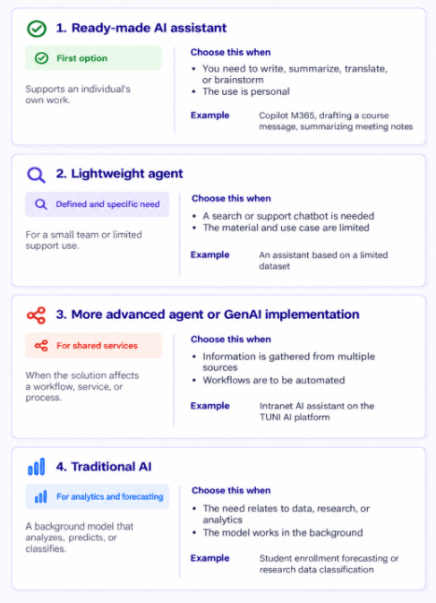
Image generated with AI

